
Ilm Ghar Online Education Platform
Project Report
FSE
Section: BAI-4B

Group Members:
22K-4080 Arham Hussain
22K-4004 Aarib Ahmed Vahidy
22k-4079 Partham Kumar

- Introduction
The "ILM GHAR" project aims to develop an online education platform to provide accessible and quality learning resources to users worldwide. In this report, we will outline the purpose of the project, its scope, and provide references for further information.
1.1Purpose
The primary purpose of the "ILM GHAR" platform is to democratize education by making learning materials readily available to learners regardless of their geographical location or socioeconomic background. Through this platform, users will have access to a diverse range of courses, tutorials, and educational resources covering various subjects and disciplines.
Key objectives of the "ILM GHAR" project include:
- Providing an intuitive and user-friendly interface for seamless navigation and access to educational content.
- Offering a wide selection of courses and tutorials curated by experienced educators and subject matter experts.
- Facilitating interactive learning experiences through multimedia content such as videos, quizzes, and assignments.
- Fostering a supportive online community where users can engage with peers, instructors, and mentors.
- Promoting lifelong learning and skill development by offering both academic and practical courses catering to diverse interests and career paths.

1.2 Product Scope
The scope of the "ILM GHAR" platform encompasses the following key features and functionalities:
- User Registration and Authentication: Users can create accounts, log in securely, and manage their profiles.
- Course Catalog: A comprehensive catalog of courses spanning various subjects, disciplines, and proficiency levels.
- Course Enrollment: Users can browse courses, enroll in their preferred courses, and track their progress.
- Interactive Learning Resources: Courses may include video lectures, reading materials, assignments and discussion forums.
- Community Engagement: Users can interact with instructors and fellow learners, ask questions, participate in discussions, and share insights.
- Admin Dashboard: An administrative interface for managing courses, user accounts, content moderation, and analytics.

1.3 References
The development of the "ILM GHAR" platform draws inspiration and guidance from various sources, including:
- Best practices in online education and e-learning platforms.
- Research articles, whitepapers, and case studies on educational technology and digital learning.
- Feedback and insights gathered from educators, learners, and industry professionals during the project's planning and development phases.
- Open-source software libraries, frameworks, and tools used in the development of the platform.
- Legal and regulatory frameworks governing online education, data privacy, and intellectual property rights.
These references serve as valuable resources for informing the design, development, and implementation of the "ILM GHAR" platform, ensuring its effectiveness, accessibility, and relevance to users' needs.

2. Overall Description
In this section, we provide an overview of the "ILM GHAR" platform, including its product perspective, functions, user classes, operating environment, design constraints, user documentation, and assumptions.
2.1 Product Perspective
The "ILM GHAR" platform operates as an independent online education portal, providing a centralized hub for learners to access a wide range of educational content.
2.2 Product Functions
Key functions of the "ILM GHAR" platform include:
- User Registration and Authentication: Allow users to create accounts, log in securely, and manage their profiles.
- Course Management: Provide administrators with tools to create, publish, and manage courses, including adding multimedia content, and assignments.
- Course Enrollment: Enable users to browse courses, enroll in their preferred courses.
- Interactive Learning Resources: Offer multimedia learning materials such as video lectures, reading materials, and discussion forums.
- Community Engagement: Facilitate interaction among users, instructors, and mentors through discussion forums, messaging, and collaboration tools.
2.3 User Classes and Characteristics
The "ILM GHAR" platform caters to the following user classes:
- Learners: Individuals seeking to acquire new knowledge, skills, or qualifications through online courses.
- Instructors: Educators, subject matter experts, and content creators responsible for developing and delivering course content.
User characteristics may vary, including educational background, proficiency level, learning goals, and preferences for course formats and subjects.
2.4 Operating Environment
The "ILM GHAR" platform operates in a web-based environment, accessible through modern web browsers on desktop, laptop, and mobile devices. It requires an internet connection for users to access course content, interact with other users, and participate in online activities.
2.5 Design and Implementation Constraints
Design and implementation constraints of the "ILM GHAR" platform include:
- Compatibility: Ensuring compatibility with a wide range of devices, browsers, and screen sizes to accommodate diverse user preferences and accessibility needs.
- Scalability: Designing the platform architecture to scale efficiently as the user base and content library grow over time.
- Security: Implementing robust security measures to protect user data, prevent unauthorized access, and mitigate risks such as data breaches and cyberattacks.
- Usability: Prioritizing user experience and intuitive design to make the platform accessible and engaging for users of all skill levels.
2.6 Assumptions and Dependencies
Assumptions and dependencies of the "ILM GHAR" platform include:
- Availability of Internet Access: Users require a stable internet connection to access the platform and its content.
- Content Development: The platform relies on instructors and content creators to develop and contribute course materials.
- Regulatory Compliance: The platform complies with relevant laws and regulations governing online education, data privacy, and intellectual property rights.
- Technology Infrastructure: The platform relies on underlying technology infrastructure, including servers, databases, and hosting services, to operate effectively and securely.

3. External Interface Requirements
This section outlines the external interfaces of the "ILM GHAR" platform, including user interfaces and software interfaces.
3.1 User Interfaces
The user interfaces of the "ILM GHAR" platform are designed to be intuitive, user-friendly, and accessible across various devices and screen sizes. Key user interfaces include:
- Registration and Login: Users can register for an account or log in using their email address and password. The registration form collects basic user information such as name, email, and password.
- Dashboard: Upon logging in, users are greeted with a personalized dashboard that provides an overview of their enrolled courses, progress, and notifications. The dashboard serves as a central hub for accessing course content and platform features.
- Course Catalog: The course catalog displays a searchable list of available courses, including course titles, descriptions, and instructor information. Users can filter courses by category, and view detailed course pages for more information.
- Course Content: Course pages feature multimedia content such as video lectures, reading materials, and assignments. Users can navigate through course modules, and interact with instructors and fellow learners.
- Discussion Forums: Discussion forums allow users to engage in discussions, ask questions, and share insights with other learners and instructors. Users can create new discussion topics, reply to existing threads, and upvote or downvote posts.
- Profile Management: The profile management interface enables users to update their profile information, upload a profile picture, and manage their account settings such as email preferences and password.
3.2 Software Interfaces
The "ILM GHAR" platform interacts with various software components and external services to provide its functionality. Key software interfaces include:
- Database Management System (DBMS): The platform relies on a relational database management system (RDBMS) such as MySQL or MariaDB to store and manage user data, course content, and system configurations.
- Web Server: The platform is hosted on a web server that serves web pages, processes user requests, and interacts with the database server to retrieve and store data.
- Content Delivery Network (CDN): Multimedia content such as video lectures and images may be delivered through a content delivery network to optimize performance and reduce latency for users accessing the platform from different geographic locations.
- Payment Gateway: If the platform offers paid courses or premium features, it may integrate with a payment gateway service to facilitate secure online payments and subscription management.
- Authentication Service: The platform may integrate with third-party authentication services such as OAuth or OpenID Connect to enable single sign-on (SSO) and allow users to log in using their existing credentials from other platforms.
- Analytics and Reporting Tools: The platform may integrate with analytics and reporting tools to track user engagement, monitor course performance, and generate insights for administrators and instructors.
These interfaces ensure seamless communication and interoperability between the "ILM GHAR" platform and external systems, enabling efficient operation and enhanced user experience.

4. System Features
This section outlines the key features of the "ILM GHAR" platform.
4.1 User Login
- Description: Allows users to securely log in to their accounts using their registered email address and password.
- Functionality:
  - Users enter their email and password on the login page.
  - The system verifies the credentials against the database.
  - Upon successful authentication, users are redirected to their personalized dashboard.
  - Failed login attempts trigger appropriate error messages and prompts for re-entry.
4.2 Adding Teachers
- Description: Enables administrators to add new teachers to the platform.
- Functionality:
  - Administrators access the administrative dashboard.
  - They navigate to the teacher management section.
  - A form is provided to enter the teacher's name, email, profession, and profile picture.
  - Upon submission, the teacher's profile is added to the database, allowing them to access the platform as instructors.
4.3 Teacher Management
- Description: Facilitates the management of teachers' profiles and courses they offer.
- Sub-features:
  - 4.3.1 Adding Courses
    - Description: Allows teachers to create and add new courses to the platform.
    - Functionality:
      - Teachers access their dashboard and navigate to the course creation section.
      - They provide details such as course title, description, thumbnail image, and category.
      - Additional options may include setting course prerequisites, enrollment limits, and pricing.
      - Upon submission, the course is added to the course catalog and becomes available for enrollment.
  - 4.3.2 Editing Courses
    - Description: Enables teachers to modify existing course details and content.
    - Functionality:
      - Teachers access the course management interface for the course they wish to edit.
      - They can update course information such as title, description, and thumbnail image.
      - Teachers may also add, remove, or rearrange course modules, lectures, and assignments.
      - Changes made to the course are reflected in the course catalog and accessible to enrolled users.
These system features empower administrators and teachers to effectively manage user accounts, course offerings, and content on the "ILM GHAR" platform, ensuring a seamless and enriching learning experience for all users.

5. Other Nonfunctional Requirements
5.1 Performance Requirements
- Description: The system must be capable of handling multiple concurrent users and provide responsive performance.
- Performance Criteria:
  - Response time for user interactions should be within 2 seconds.
  - System downtime should not exceed 1% of total operational hours.
  - The platform should support at least 1000 simultaneous users without significant degradation in performance.
5.2 Security Requirements
- Description: Security measures must be implemented to protect user data, authentication processes, and system integrity.
- Security Measures:
  - User authentication: Implement secure login mechanisms such as password hashing and session management.
  - Data encryption: Encrypt sensitive user information during transmission and storage.
  - Role-based access control: Ensure that users have appropriate access permissions based on their roles (e.g., administrator, teacher, student).
  - Regular security audits: Conduct periodic assessments and vulnerability scans to identify and address potential security risks.
  - Secure coding practices: Follow best practices for secure coding to prevent common vulnerabilities such as SQL injection.
These nonfunctional requirements ensure that the "ILM GHAR" platform delivers reliable performance and maintains the confidentiality, integrity, and availability of user data and system resources.

Use Case and Activity Diagram
6.1 Use Case diagram
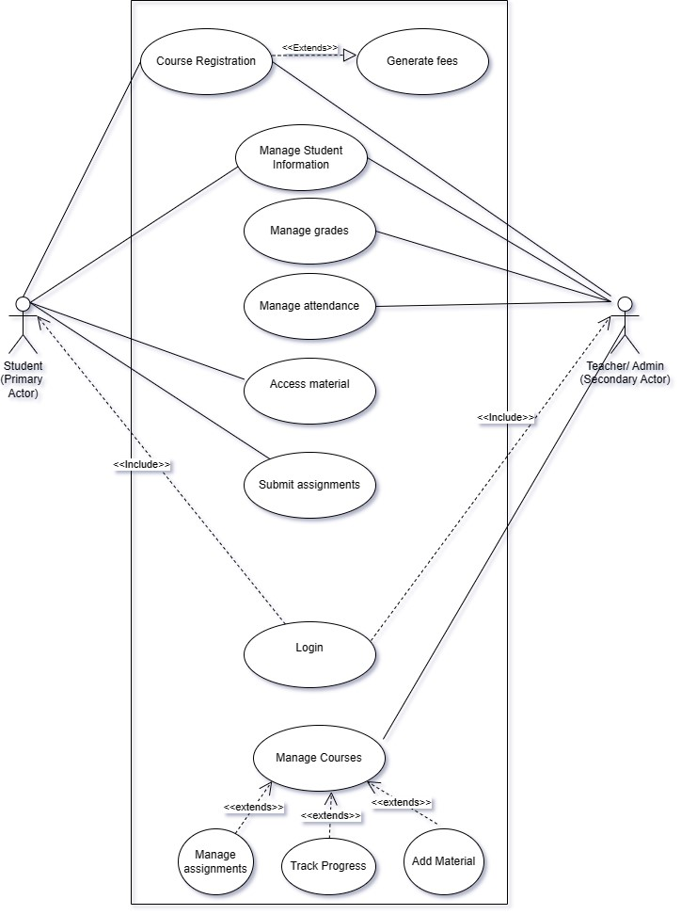

6.2 Activity diagram
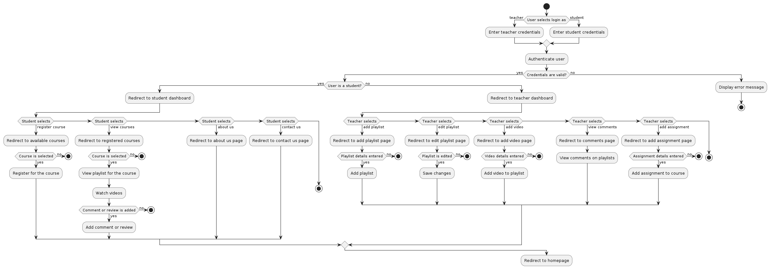

  - Sequence diagram

    - Student Sequence Diagram
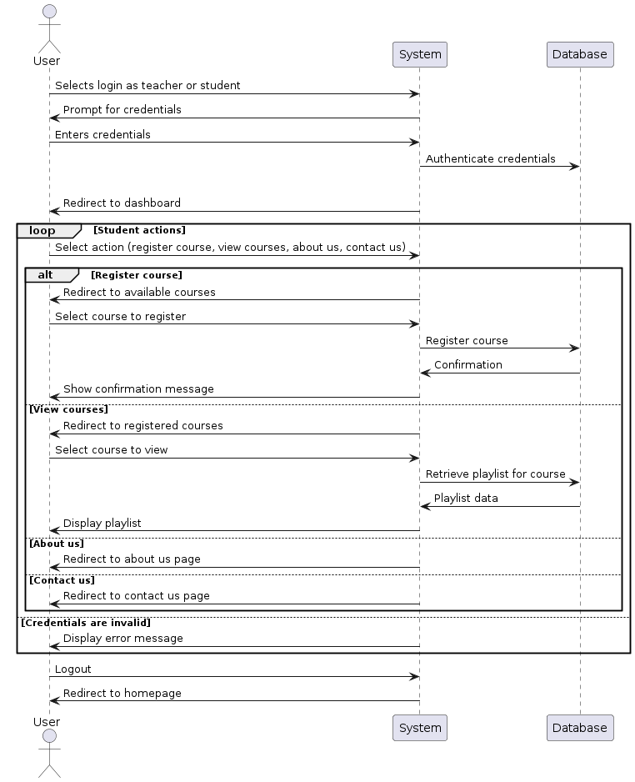

    - Teacher/Admin Sequence Diagram
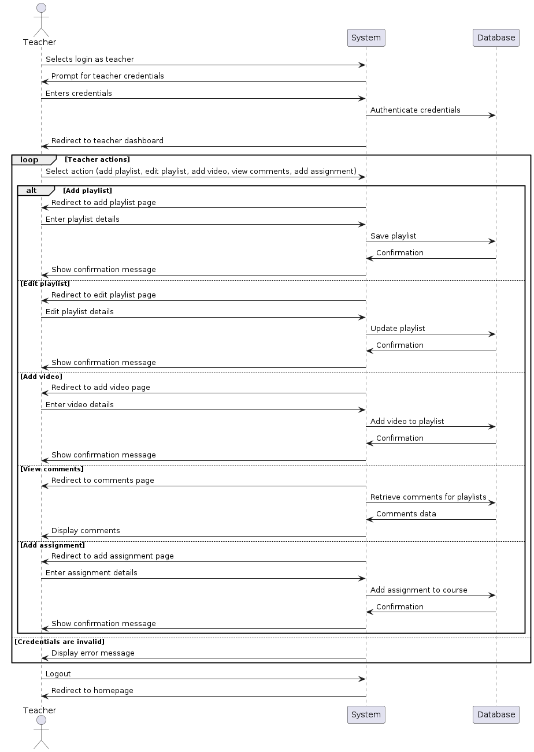

  - State diagram

    - Student State Diagram
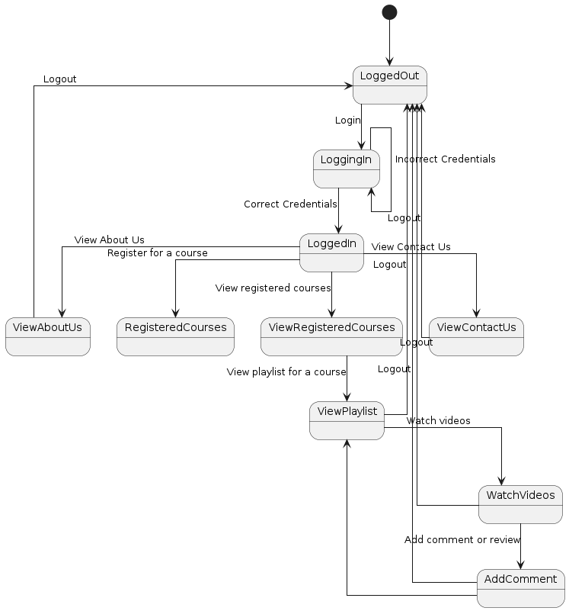

    - Teacher State Diagram
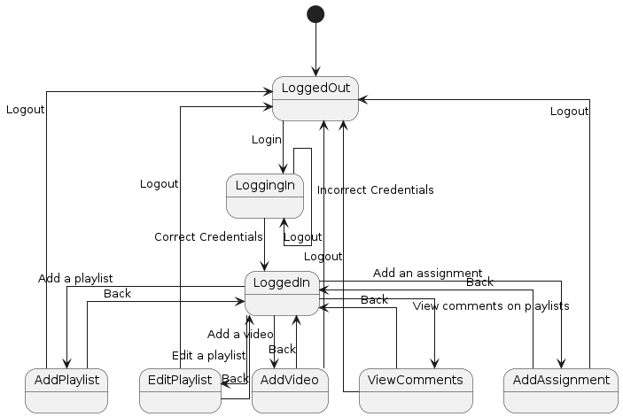
7. Testing
7.1 Test Cases
- User Login Validation:
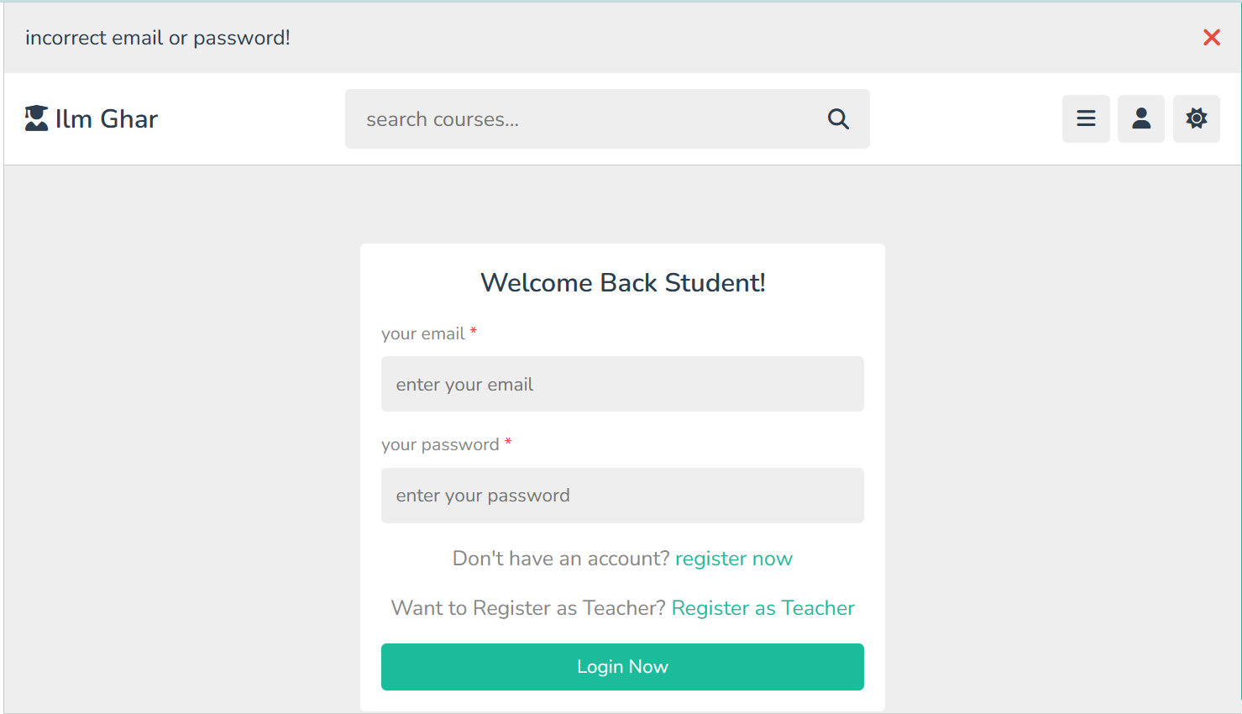

- User Courses Registration Validation (Cannot Register Already Registered Course)
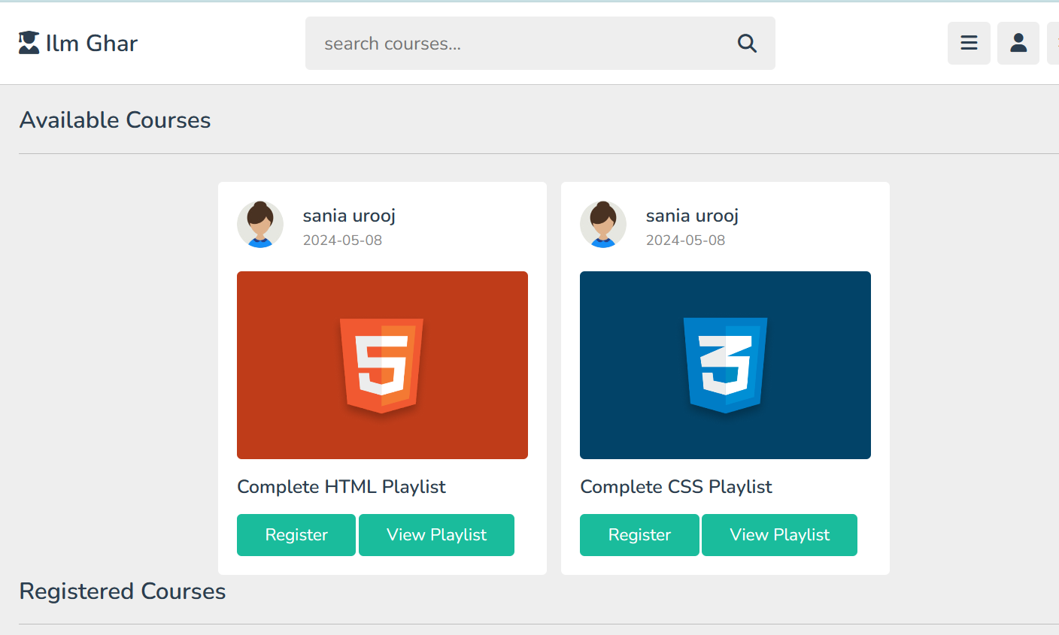

- Filling All the fields (For Assignments and Course content):

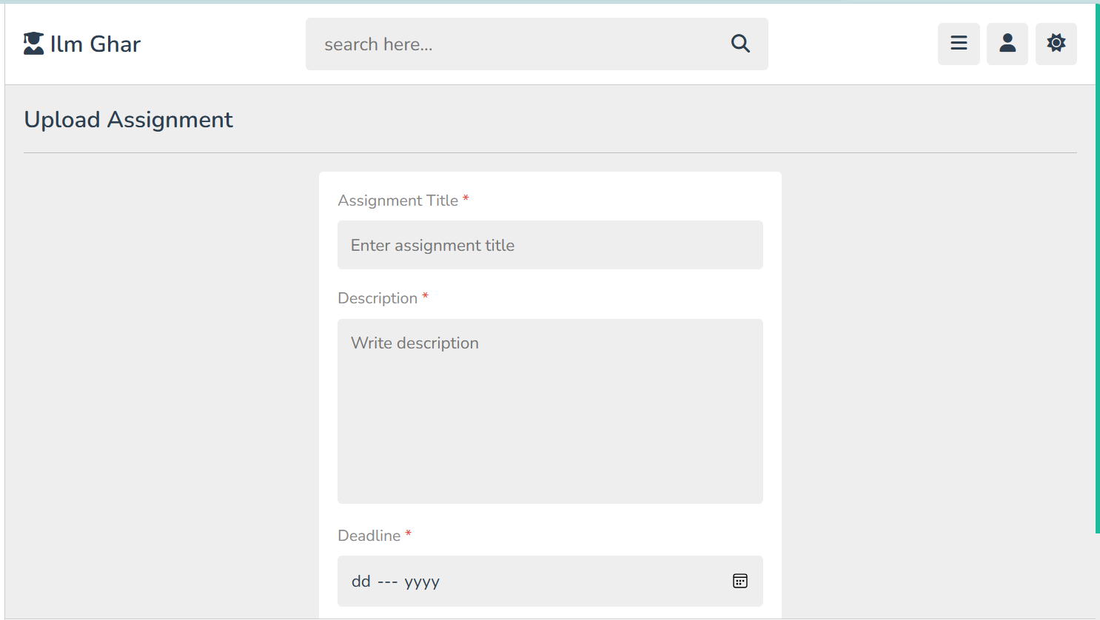

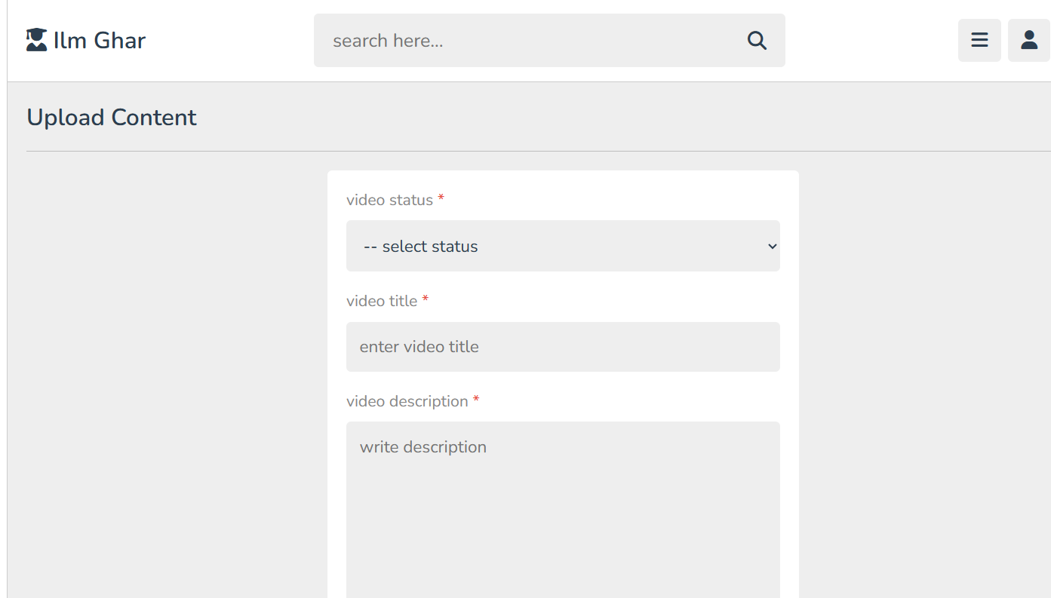

8. Gantt Chart
